My Guitar Book



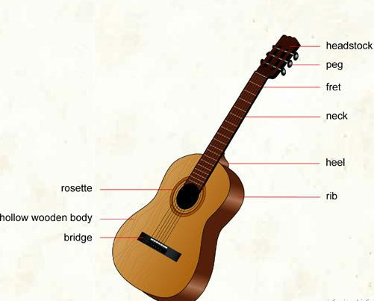

Name:- _______________________
Standard Tuning:-

E at
A pples
D aily
G row
B ig
E ars

Many other tunings exist, But are mainly used in traditional Folk and Blues Music. We may look at some of these much later in the course.

